A survey design on post-implementation of Next Generation Delivery Model (NGDM) to assess motivation quotient of leveraged agents.
Adrian Cuyugan
Master of Statistics, UP Diliman QC

Table of Contents
A survey design on post-implementation of Next Generation Delivery Model (NGDM) to assess motivation quotient of leveraged agents. 4
Background of the Study 4
Review of Related Literature 4
Proposed Statement of the Problem 7
Proposed Methodologies 8
Design and limitations 8
Participants 8
Measures 9
Procedures 11
Statistical methods 11
Schematic design 13
Project Management 14
Overhead and budget 14
Transportation and communication 14
Training and fieldwork 14
Data processing 14
Report writing 14
Timeline 15
References 16

A survey design on post-implementation of Next Generation Delivery Model (NGDM) to assess motivation quotient of leveraged agents.

Background of the Study
Companies, particularly Business Process Outsourcing (BPO) industries, have started to leverage employees by engaging them into different accounts/clients to maximize its key resources while minimizing the additional requirement in hiring new employees. Computer Sciences Corporation (CSC) recently implemented a change, through this next generation delivery model, the tenure employees which have been assigned to a specific client, would need to support two or more clients using the specific skillset the employee specializes.
- Old model – an agent is assigned to Account A supporting an IT infrastructure X.
- New model – an agent is assigned to Account A, B and C supporting an IT infrastructure X.
Certain factors may affect client engagement, employee satisfaction, work stress and delivery output may be affected after implementing the new model as I was affected to this change, thus making this a notable interest for me to study.
Keywords: organizational behavior, motivation

Review of Related Literature
According to Maslow, there are five levels of needs for employees (Maslow, 1943). Before the higher level of needs to be satisfied, the lower level of needs (as shown in the hierarchy) need to be fulfilled and satisfied first.

Figure 1- Employee Hierarchy of Needs according to Maslow

There are two categories of motivation: intrinsic and extrinsic factors (Herzberg, Mausner, & Snyderman, 1959).
Extrinsic motivation. These are also called motivators that can have immediate effect on employees but does not usually last long (Mullins, 2005) (Armstrong, 2006). Examples of which are fringe benefits, promotion, security and work environment. These are motivators determined at the organization level, usually outside the control of immediate supervisors.
Intrinsic motivation. Having a sense of belonging, challenge and achievement, receiving good feedback and praises from peers, recognition are motivators that affect the quality of life at work which are usually dependent on the actions of immediate supervisors (Mullins, 2005). Compared to the former, this has longer effect on the employees’ motivation (Armstrong, 2006).
Operationally, the motivation for this study is defined as factors that engages employees to accomplish their personal and organization goals after a change.
Using the full talent and abilities of an employee depends on the success of any organization. The most important reason for not being productive at work is the loss of morale: without positive reinforcement from supervisors, not having sense of belonging and receiving undervalued recognition (Mullins, 2005).
Figure 2 - Illustration of basic motivational model (Mullins, 2005)
An employee should be given a task that he has been trained for so that he can perform well. Any employee should also be given proper training and support to develop their talents and abilities, expanding their full potential (Osabiya, 2015). If the employee is highly motivation, they strive for higher belonging so that they can be identified within the organization.
So, why does the organization and immediate supervisors need to motivated their employees and subordinates? This is because of survival (Smith, 1994). Highly motivated employees help the organization survive particularly after a big change and the most impact is supported by the immediate supervisors understanding what motivates employees within the job scope they were hired and trained for (Bowen & Radhakrishna, 1991).

Proposed Statement of the Problem
The survey questionnaire composes of 16 relevant questions that may affect motivation quotient. The main study focuses on, “What is the current motivation quotient of the tenure agents after implementing the new generation delivery model?”

Proposed Methodologies
The study covers the basic exploratory and predictive statistical methods to quantify the motivation quotient of the leveraged agents. The data used to produce the example tables and graphs were simulated using random number generation.

Design and limitations
The pilot model was implemented a year ago to a small group of highly skilled technicians/agents in IT infrastructure and IT service support groups. Then, after 6 months, the model was layered to all support groups but still retaining half of the operational workforce to remain as usual and the rest were engaged to follow the new model. The next generation delivery model may be extended to the whole company, particularly to those who belong to operations who engage in client delivery, once success is achieved based on the current key metric performances. Note that no surveys were done intended to quantify employee motivation specific prior to NGDM implementation and during the pilot phase so no comparison could be studied.

Participants
The respondents are located in different geographical locations, i.e. Philippines, USA, India, Czech Republic, Panama, Malaysia, China, etc., thus, making this questionnaire available and prepared on an online enterprise platform such as SurveyMonkey. To be eligible in the study, the respondents need to be more than a year of tenure in leveraged environment to assess only those who have been with the company for more than a year and with already significant client engagement.
The NGDM organization has approximately 1,400 employees, proportionate stratified random sample will be used to determine the sample size. Fifty-percent is currently doing the new model, so the computation will be based on 700 leveraged agents. More than 30% from each stratum, country, is randomly selected among the pool of agents which will be part of this study.
$$n_{h}=\left({N_{h}}/N\right)*n$$
where: $n_{h}$ = sample size for each stratum $h$
$N_{h}$ is the population size for the stratum $h$
$N$ is the total population and $n$ is the total sample size
Equation 1 - Proportionate Stratification

Measures
All questions are answered by dichotomous answer – Yes and No only. Four main quadrants of behaviors are studied; each quadrant contains four specific questions which encompass its respective behavior model:
- Role modeling
  - I agree with the benchmarks set for me on my team’s performance board? (Clarity and reasonableness of goals)
  - The standard claim processes / job aids clarify what is expected of me? (Effectiveness of processes)
  - The team structure and work processes support the standards expected of me? (Effectiveness of systems)
  - The performance measures motivate me to engage in an efficient recovery process? (Effectiveness of metrics)
- Fostering understanding and commitment
- The behaviors of the supervisors and managers are consistent with their communication? (Consistency of actions or communications)
- My peers display a mentality that drives cooperation? (Teamwork)
- The supervisors and managers provide recognition for improvement/high performance that is meaningful to me? (Effectiveness of rewards and recognition programs)
- The supervisors and managers promote the department’s vision? (Cheerleading)
- Developing talent and skills
- The objectives of the department are clearly defined? (Clarity of team’s objectives)
- I am familiar with the vision for the department? (Commitment to the vision)
- I understand my role in delivering on the vision of the department? (Understanding of individual role)
- I play a meaningful role in the success of the company? (Belief in the meaningful nature of individual role)
- Reinforcing with formal mechanisms
- The training I received for changes in processes was effective in enabling me to perform the work I was assigned? (Process training)
- The coaching time I spend with my supervisor is valuable? (Team manager coaching)
- I am given opportunities to come together with my team to find solutions to business issues? (Team problem solving)
- The training methods are effective in building new skills? (Effectiveness of training methods)

Procedures
Identification of the respondents will be anonymized during data preparation. Also, the respondents will be oriented by their immediate supervisors that relevant information may be gathered, sensitive information that Human Resources will only have access (i.e. standardized salary, performance rating last year, etc.), to complete the study. Option will be given to the respondent if they’ll allow to use their HR records in the study. Any of the respondent who does not permit to use their personal information will be dealt using common techniques handling missing data.

Statistical methods
Common exploratory data analysis particularly graphs will also be done particularly for numerical variables, i.e. standardized salary, scale of previous annual appraisal, etc.
Figure 3 - Example of Boxplot

Cross-tabulation of each question will be prepared and computed for chi-square of independence to find statistical significance of association in between variables producing 256 different hypotheses on the questions included in the questionnaire.
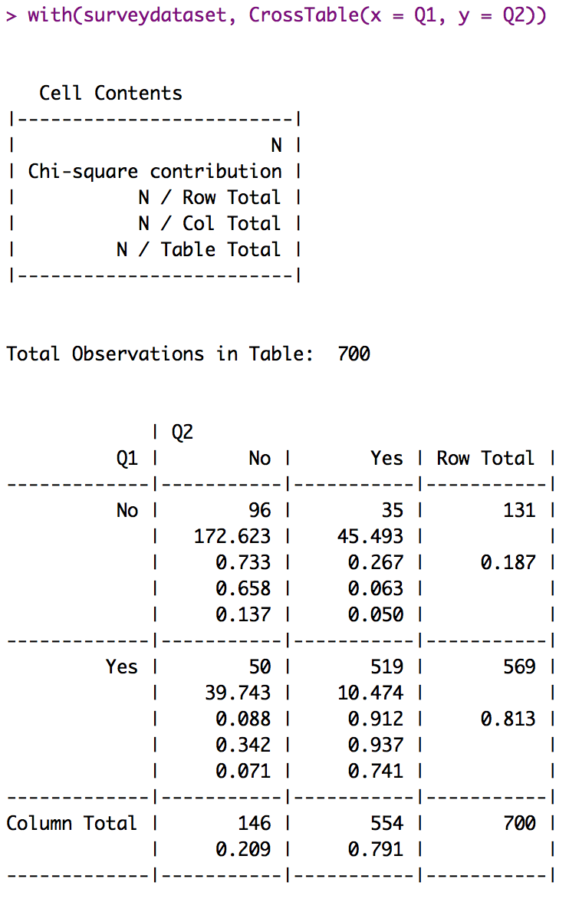
$H_{O}=$Q1 and Q2 are independent
$H_{A}=$Q1 and Q2 are not independent
Table 1- Example of Cross-tabulation of Questions and Hypothesis to be Tested

Each question will act as an independent variable and will be regressed/learned among the covariates to compute for predictive power after splitting the dataset into training, validation and test datasets, 20-20-60 respectively. Different statistical/machine learning algorithms will be used to compute for the accuracy using ROC since the independent variable [each] follows a binomial distribution. Whichever algorithm shows the highest AUC on the test dataset will be selected as the final model.
Figure 4 - Example of ROC on Test Dataset

Schematic design
Each of the dimensions will be used in the predictive modeling stage. The independent variables will be selected on all 16 questions and the models will run iteratively until all questions are modeled using the same statistical algorithm.
Figure 5 - Schematic Diagram of Covariates

Project Management

Overhead and budget
No overhead cost is estimated as this is part of an internal process of Human Resources and NGDM Operations. The cost of basic SurveyMonkey subscription is Php 1,000 pesos for one license per month with a limit of 1,000 respondents.

Transportation and communication
Separate emails will be sent to the targeted respondents and will be followed-up by their immediate supervisor to lessen the non-response rate. The survey questionnaires will be available for 5 working days.

Training and fieldwork
No training and fieldwork preparation are needed since the questionnaires will be available online for easier data collection.

Data processing
SurveyMonkey allows exportation of the raw dataset to CSV. Other data sources will be provided by the Human Resources. All data processing will be done in R.

Report writing
The audience will be senior management prepared in corporation deck of presentation slides showing the problem statement, summary of exploratory data analysis, conclusion on predictive modeling and the possible recommendations based on quantification of motivation quotient.
Figure 6 - Example of Variable Importance

Timeline
The study is staged into three phases and a day to present to the senior management:
- Approval – 5 working days
- Data collection – 6 working days (overlapped with a day on approval phase)
- Data analysis – 5 working days
Figure 7 - Proposed Timeline

References
Mullins, L. (2005). Management and Organisational Behaviour. UK: Prentice Hall.
Armstrong, M. (2006). Human Resource Management Practice. Kogan.
Maslow, A. H. (1943). A theory of human motivation. Psychological Review.
Smith, G. P. (1994). Human resources management and development handbook (Vol. 2nd). W Tracey.
Bowen, B. E., & Radhakrishna, R. B. (1991). Job satisfaction of agricultural education faculty: A constant phenomena. Journal of Agricultural Education, 32(2), 16-22.
Osabiya, B. (2015). The effect of employees’ motivation on organizational performance. Journal of Public Administration and Policy Research, 7(4), 62-75.
Champagne, P., & McAfee, B. (1989). Motivating strategies for performance and productivity: A duide to human resource development. New York: Quorom Books.
Herzberg, F., Mausner, B., & Snyderman, B. B. (1959). The motivation to work. New York: John Wiley & Sons.

